4 Marks

Maximum Marks

27 October 2022

Date

**Technology Stack (Architecture & Stack)**

Project – Analytics for Hospital Health Care Data

Project Name

**Project Design Phase-II**

PNT2022TMID27276

Team ID

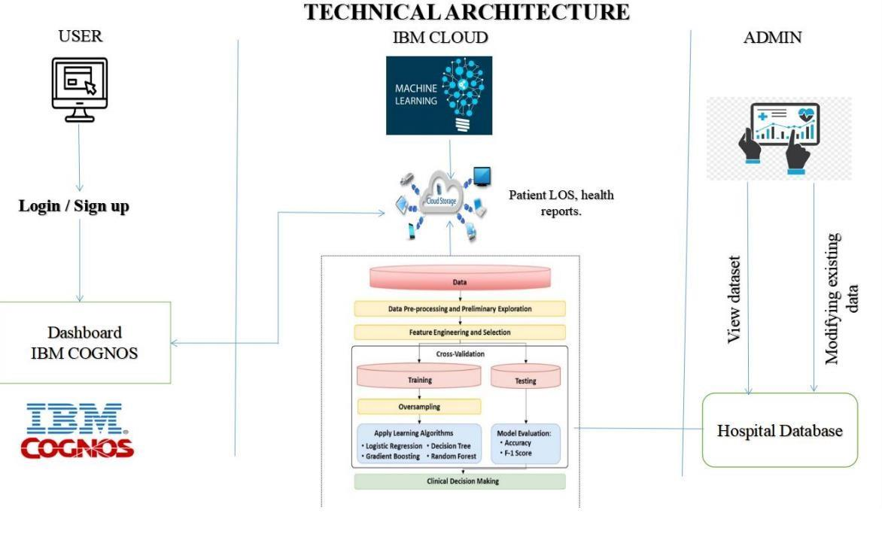

Local, Cloud storage foundry etc.

Aadhar API, PAN card etc.

Database Service on Cloud storage

MySQL, NoSQL

user interaction with web/app

File Storage

File storage requirements

IBM Block Storage or Other Storage

Service or Local Filesystems.

7.

External API-1

Purpose of External API used in the application

5.

Cloud Database

IBM Cloud etc.

6.

Local Server Configuration:

Application Deployment on Local System / Cloud

9.

Infrastructure (Server/Cloud)

Cloud Server Configuration:

Machine Learning Model

8.

Purpose of Machine Learning Model

Regression Model, etc.

1.

User Interface

Java script, CSS, html

.

**S. No**

**Component**

**Description**

**Technology**

IBM Watson Assistance

4.

Database

Data Type, Configurations

2.

Application Logic-1

Logic for a process in the app

Python

**Table-1: components & technologies:**

3.

Application Logic-2

Logic for a process in the app

won’t function

Supports higher workloads.

High availability enables your IT

4.

Availability

Justify the availability of application (e.g use of

load balancers, distributed servers etc.)

infrastructure to continue functioning

even when some of its components

3.

Scalable Architecture

Justify the scalability of architecture (3 – tier,

Micro-services)

tools, process, and ideas in a scientific

Cache, use of CDN’s) etc.

meth to improve the desired

outcomes of individuals and

organizations.

application (number of requests per sec, use of

5.

Performance

Design consideration for the performance of the

A field of practice that uses various

**Description**

**Technology**

1.

Open-Source Frameworks

**S. No**

**Characteristics**

implemented, use of firewalls etc.

Security Implementations

List all the security / access controls

Encryption, Firewall, Antivirus.

2.

List the open-source frameworks used

Python

**Table-2: Application Characteristics:**